How to Request Alternative Media through AIM

Overview

To request alternative media each semester, you must log into AIM, which is the new platform DSP will be using to keep information about your accommodations.

Logging into AIM and Finding Your Classes
1. Use your UC Berkeley ID and Password to log into AIM via this link:
https://bachelor.accessiblelearning.com/Berkeley/
2. After logging in, make sure you are in the “My Dashboard” tab.
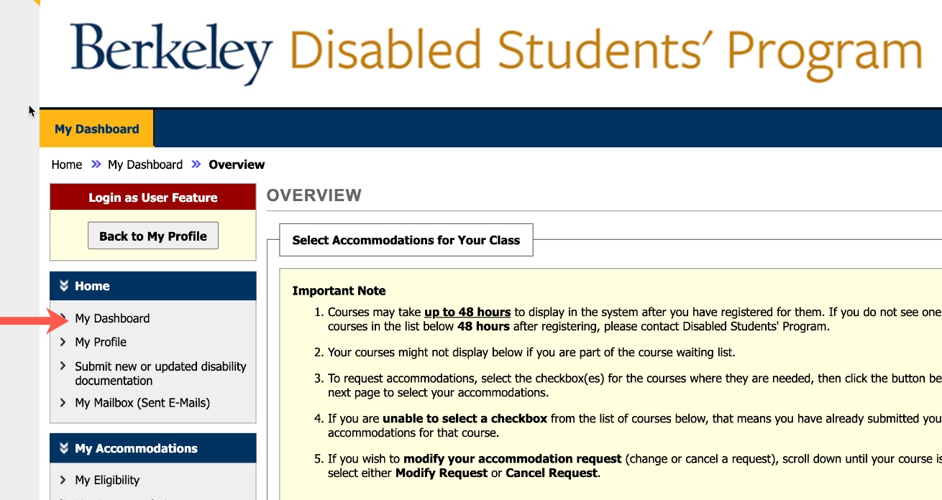

3. Scroll down to the section titled “Select Accommodations for Your Class” to find your current registered classes.
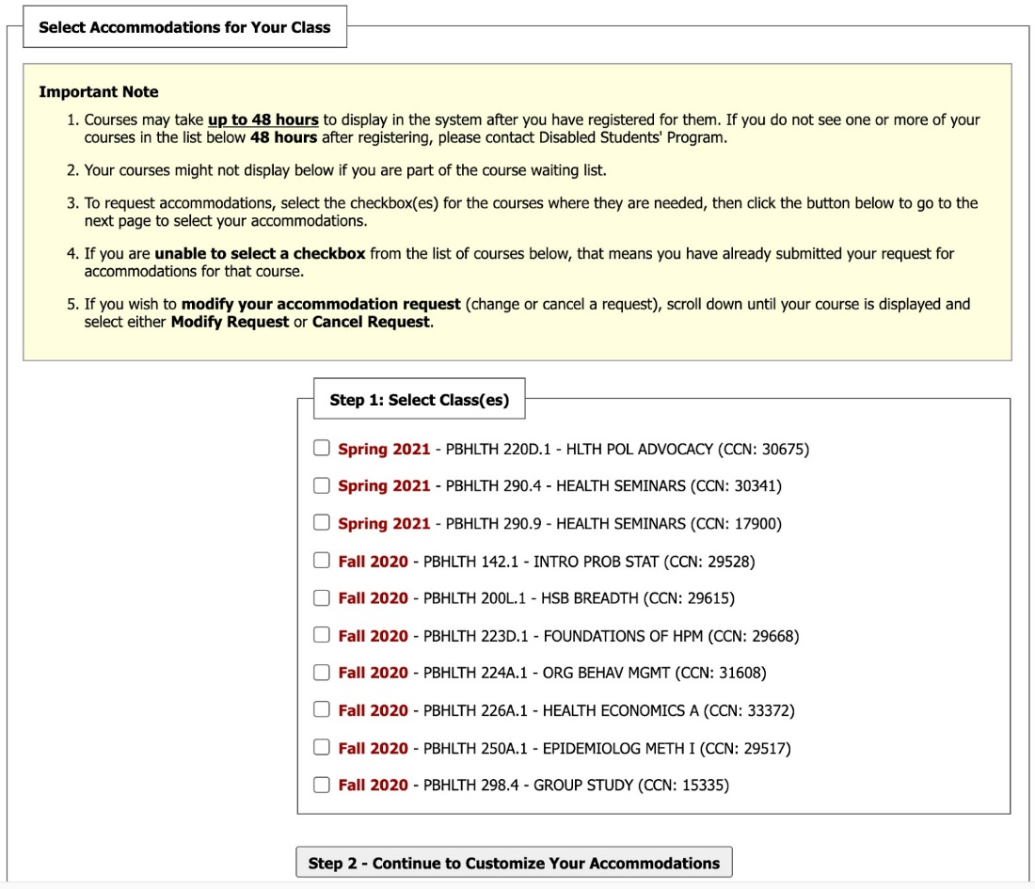

Requesting Accommodations
1. Under “Step 1: Select Class(es),” select the classes for which you wish to use alternative media by checking the box next to each course.
2. Click “Step 2: Continue to Customize Your Accommodations” to begin selecting alternative media for each class. If you are eligible for multiple accommodations, they will all be displayed on this screen under each course. Make sure to select E-Text.
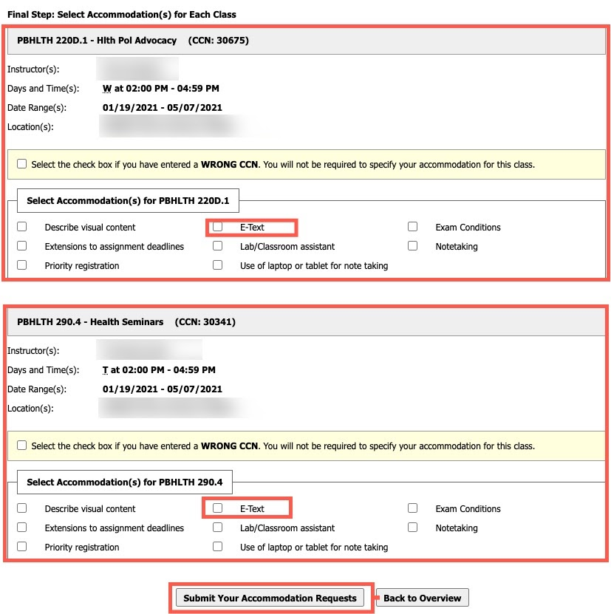

3. When you have finished selecting E-Text for each of your classes, click the “Submit Your Accommodation Requests” button at the bottom of the page. You are now ready to begin requesting alternative media for your classes.
Note: As an Alternative Media student you will also need to complete the Alternative Media Agreement Form which stipulates the conditions under which you can use the alternative media that we will be creating for you.

Requesting Alternative Media
1. Click on the Alternative Formats link under My Accommodations; click on Next Term to make sure that the correct term is the active semester.
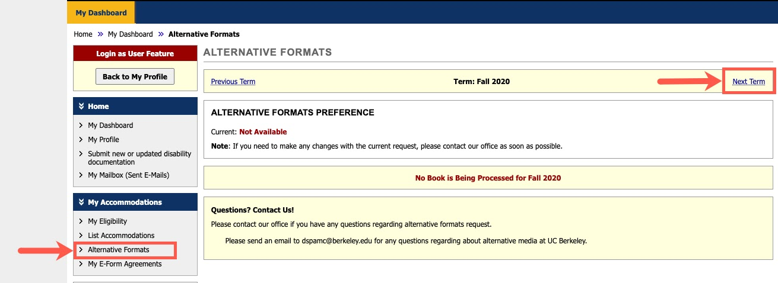
2. Scroll down to the Request Alternative Formats section. If the professor has already posted book information at the bookstore, books will be listed below. Click on the Select button for each of the books that you would like to request.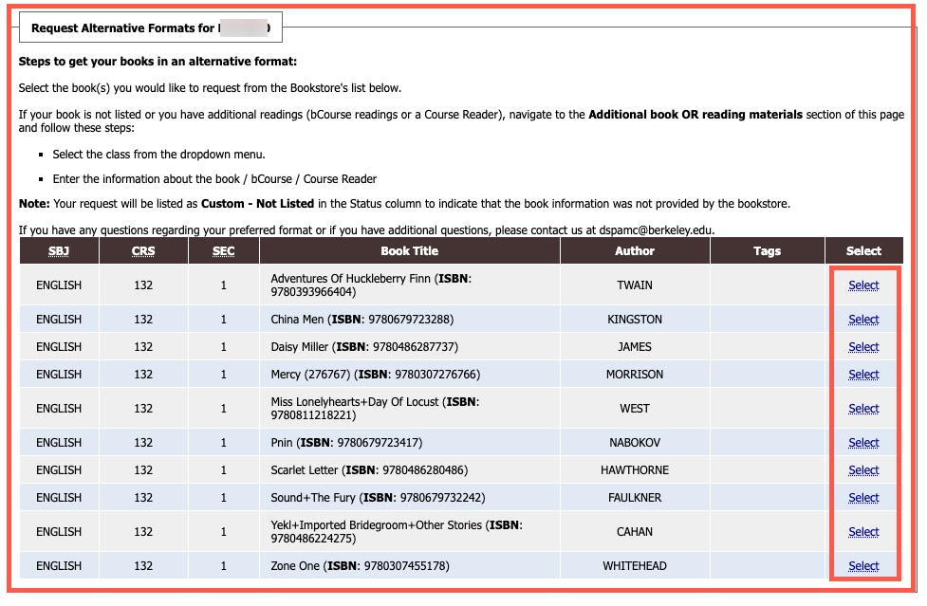

3. If you have a receipt for the book(s) you are requesting, scroll down to the Upload Book Receipt section. Click on the Choose File to browse to the location of your receipt, select the course(s) the receipt is for and click Upload Receipt. Remember that we will not share alternative media for books unless we have received a receipt from you.
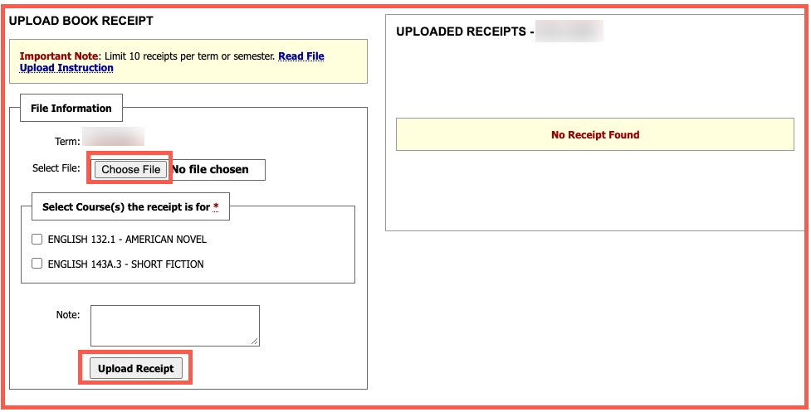

4. If your book is not listed within AIM or if you would like to request the bCourse or Course Reader for a class, please scroll down to the Additional Book or Reading Materials section and read the instructions carefully. Select the class that this additional request belongs to. For books, enter as much information as possible (Title, Author, ISBN, Edition); for bCourses or Course Readers, please indicate bCourse or Course Reader in the Title field. Then click Submit Request.
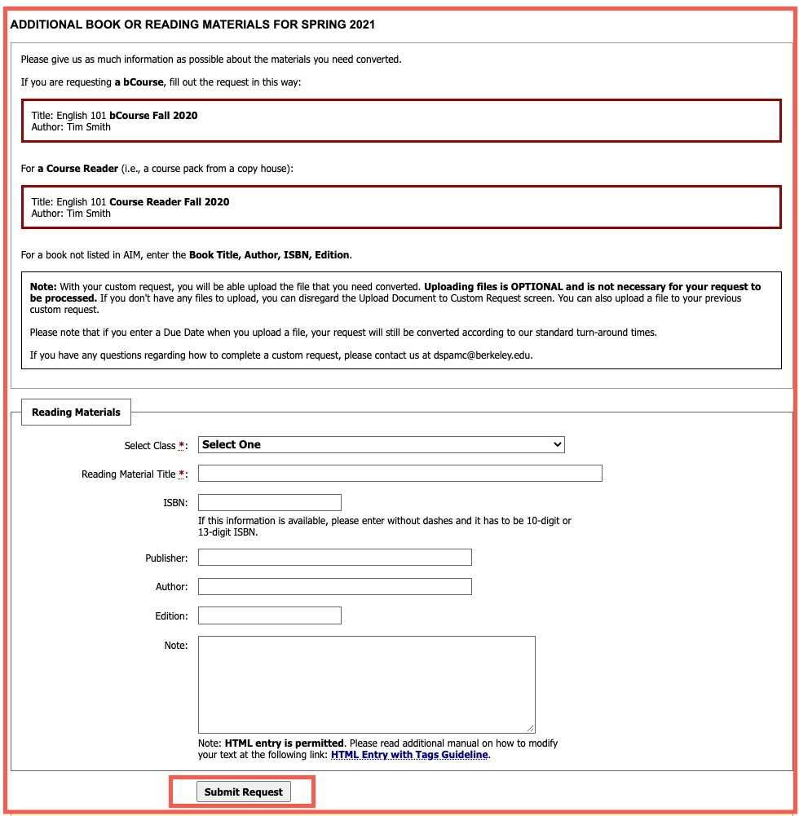
Note: If you are not sure what to request for your classes because your professor has not posted any book information, please use our Alternative Media Notice Form. The DSP Alternative Media unit will get in touch with your professors about your reading materials and will notify you about what you need to request. Once you have information about the readings for your class, follow the above steps in AIM.

Uploading Documents for Conversion
When you submit a custom request, you may also upload the document (<20 MB) you need converted.
1. In the File Information screen, enter the name of the Document, browse to file on your computer, enter a due date*, and (optional) add any notes about the file (e.g., I just need pages 1-40 converted).
2. Click Upload Document (Additional Reading Material)
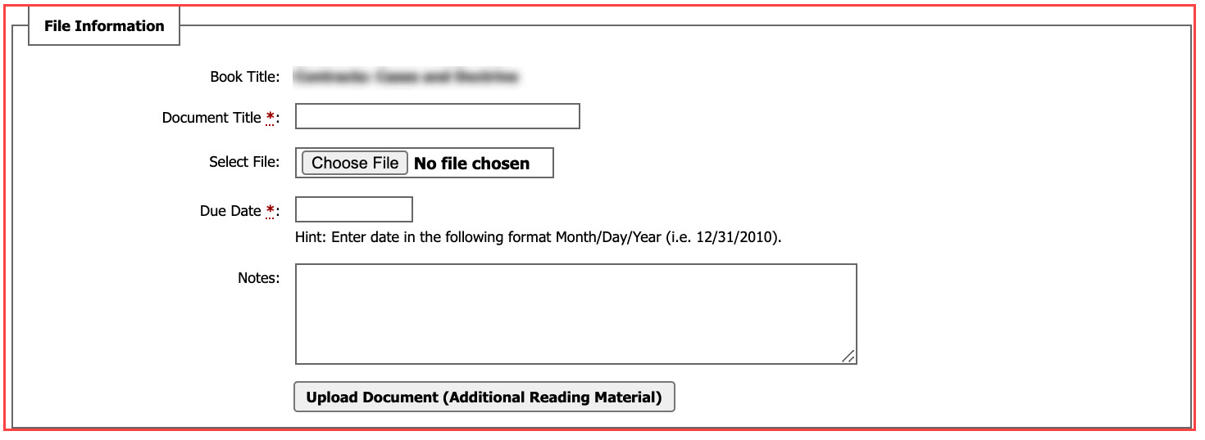
NOTE: You can upload a file to your previous custom request if you do not have it at the time of your request.
* Our standard turn-around times are still in effect for custom requests for alternative media.

Check the Status of Your Alternative Media
Once your request for alternative media has been submitted, you may track the status of your request by following these steps:
1. Click on the Alternative Formats link under My Accommodations.
2. Find the book or additional request listed under List Books Currently Being Processed.
3. Check the status of the request in the Status Column.
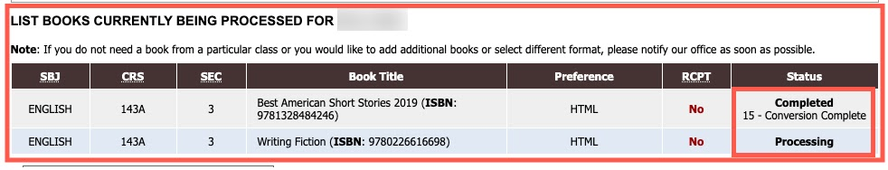

Accessing Your Alternative Media
Once your files have been converted, there will be a Download Book link in the Status column that you can use to access your alternative media.
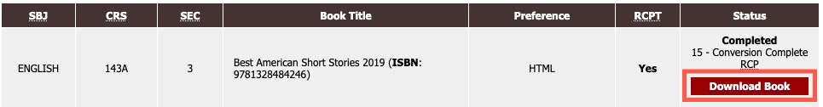
Note: Starting Spring 2021 semester, all alternative media will be posted to a Google Drive folder.

Frequently Asked Questions:
Q: What if my professor(s) has not posted any textbooks at the bookstore and I am not sure what to request for next semester?
A: If you are not sure what to request, please use our Alternative Media Notice Form and the alternative media unit will contact your professors to find out the book information. Once we receive this information, we will share it with you. Please note, once you receive information about the reading materials for a class, it is your responsibility to submit a request in AIM using the steps outlined above.

Q: How long will it take to receive alternative media?
A: Turn-around times vary based on 1) when you make the request, 2) when we receive the materials to convert, and 3) the complexity of the materials you have requested. If your request is made at least three weeks prior to the academic term, the typical turn-around time for standard books is 10-14 business days and 15-21 business days for more complex materials (STEM content, Braille, and Tactile Graphics). If your request for alternative media is made less than three weeks before the semester, we cannot guarantee that you will receive your request according to the turn-around times above.

Q: What tools can I use to access text for my classes while I wait for my alternative media?
A: For materials uploaded to bCourses, you can use Ally in bCourses. To convert files you already have on your computer, you can use SensusAccess.

Note: If you have any difficulty with these steps or have questions, please email us at dspamc@berkeley.edu.

This guide was adapted with permission from Willamette University's Accessible Education Services Department.

