How to Request Communication Accommodations through AIM

Overview:
To request communication accommodations each semester, you must log into AIM, which is the new platform DSP will be using to process your accommodations.

Logging into AIM and Finding Your Classes:
- Use your UC Berkeley ID and Password to log into AIM via this link: https://bachelor.accessiblelearning.com/Berkeley/
- After logging in, make sure you are in the “My Dashboard” tab.
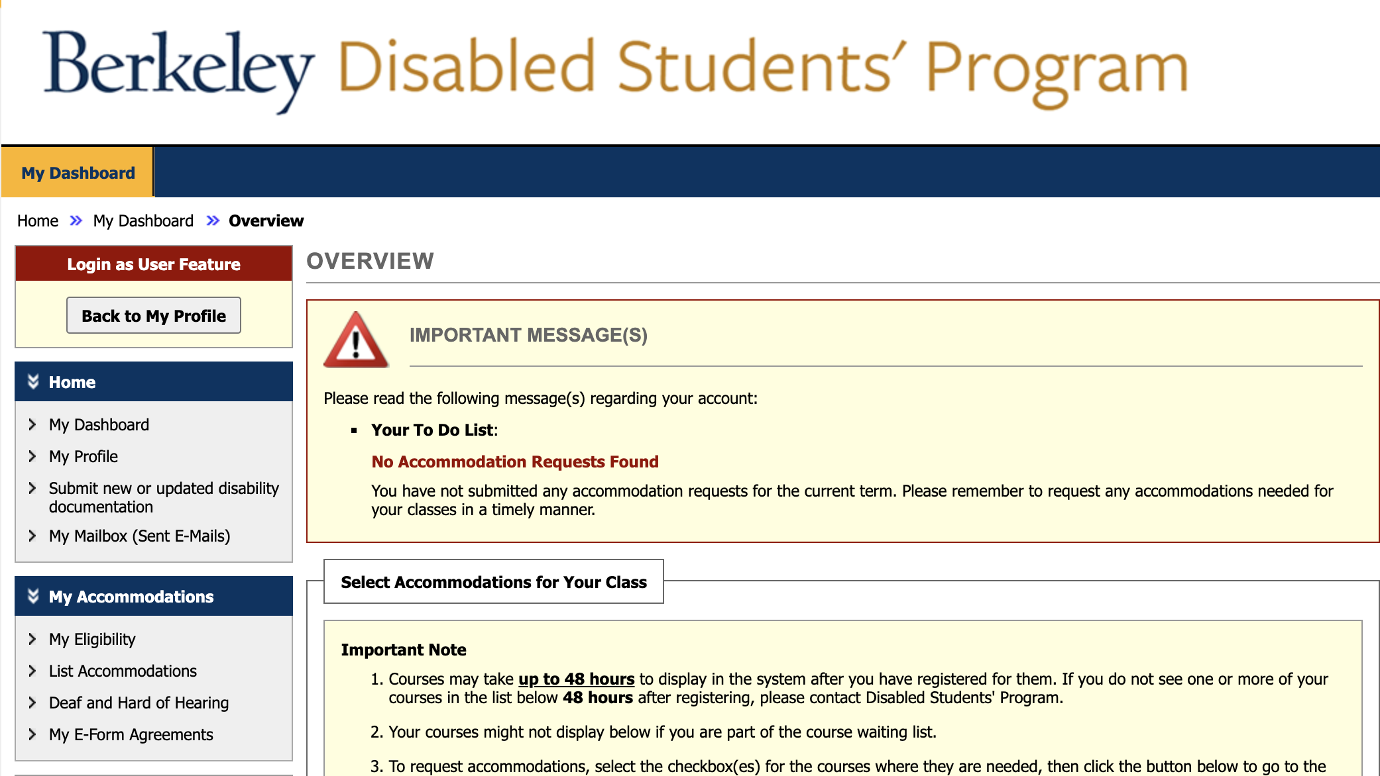
- Scroll down to the section titled “Select Accommodations for Your Class” to find your current registered class(es) with UC Berkeley. If you do not see a course you believe you are registered for, check the “Important Notes” in the yellow box above your classes.

Requesting Accommodations:
1. Under “Step 1: Select Class(es),” select the class(es) for which you wish to receive communication accommodations by checking each course’s corresponding box (see the screenshot below).
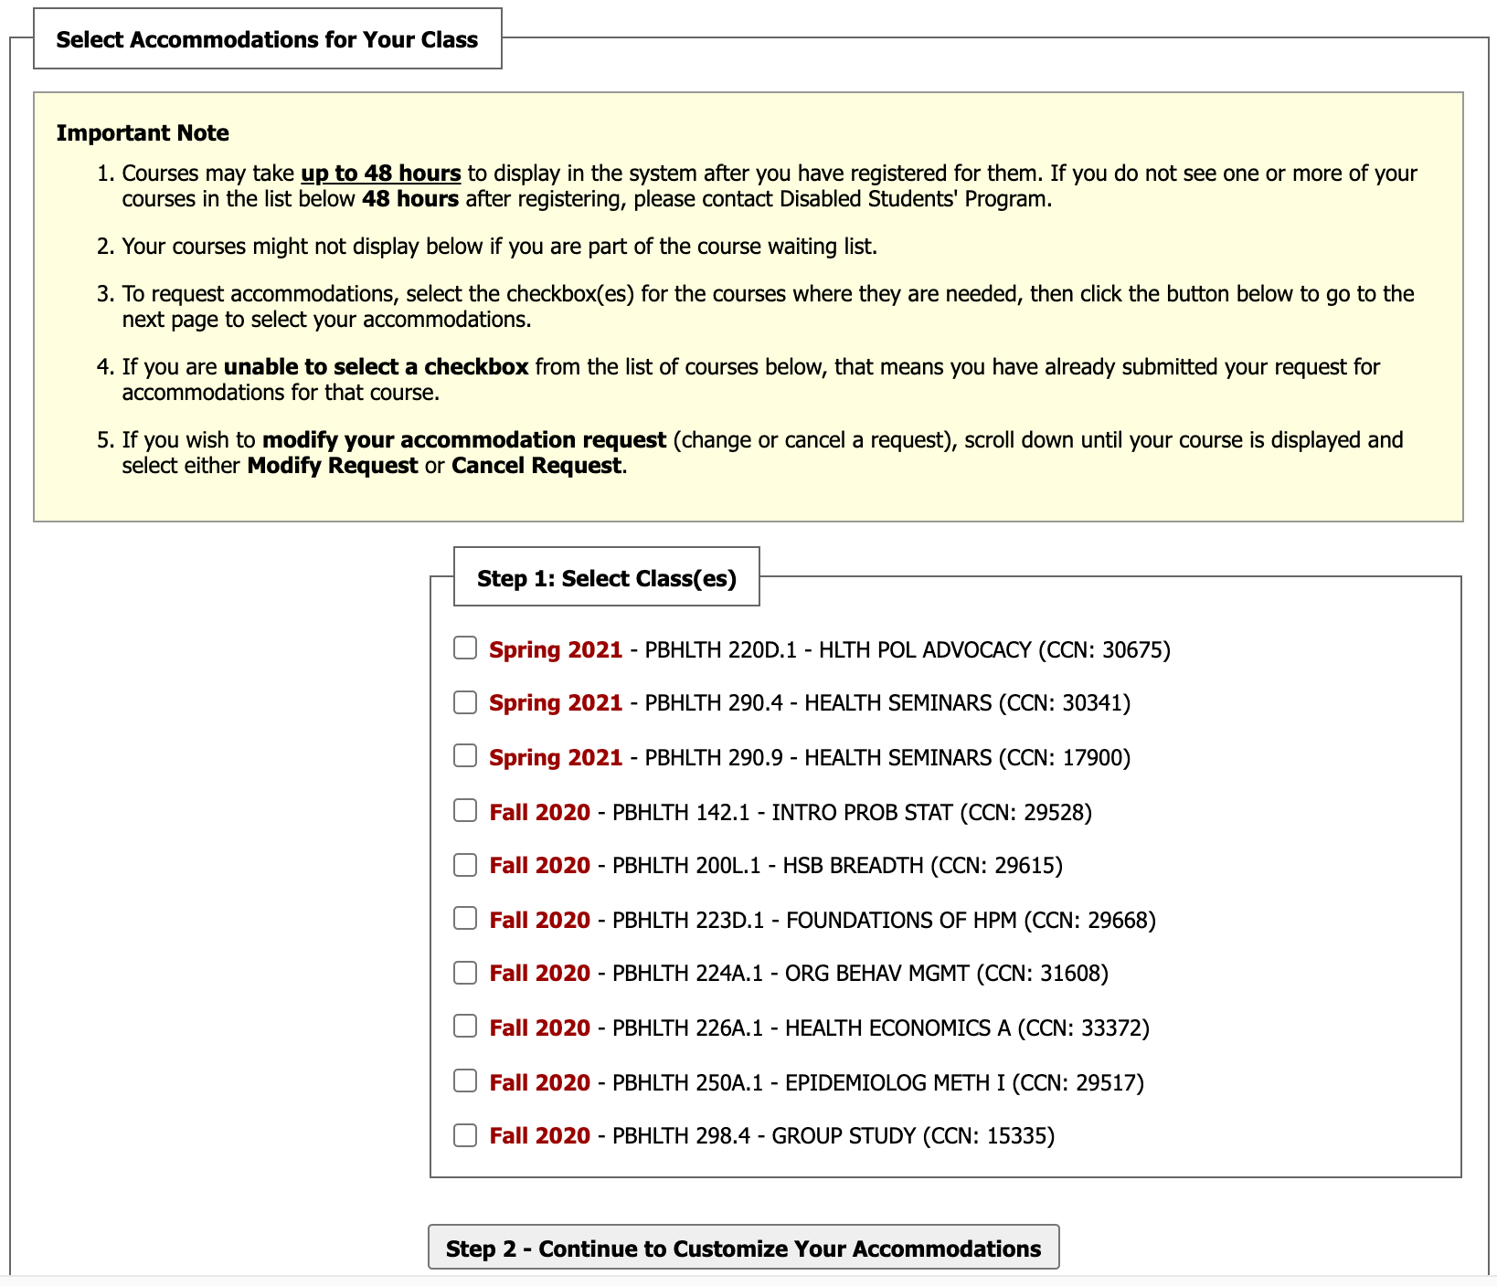

2. Click “Step 2: Continue to Customize Your Accommodations” to begin selecting accommodations for each class. If you have multiple accommodations available, they will all be displayed on this screen under each individual course you have selected. For example, in the screenshot below, the student is eligible for multiple communication accommodations.

3. When you have finished selecting your accommodations for each of your classes, click the “Submit Your Accommodation Requests” button at the bottom of the page. This will submit your request for accommodations to the DSP office. Once processed, DSP will email your Faculty Notification Letter to both you and your instructors. At that time, your accommodations for the current semester will be listed on the “My Dashboard” tab.
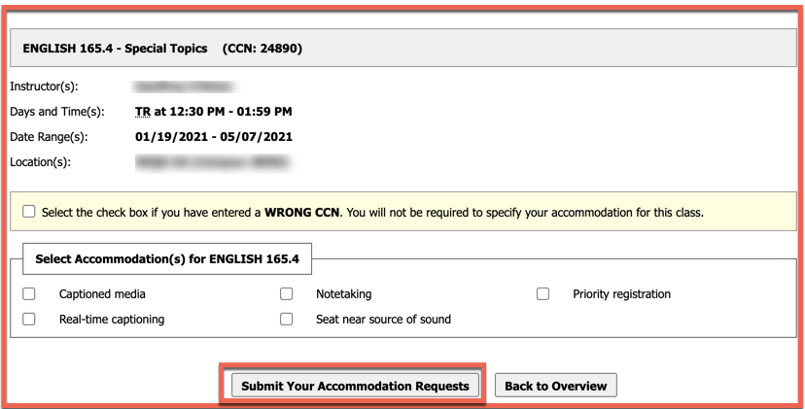
If you have any difficulty with these steps or have questions, please contact Trennad@berkeley.edu

